

Dental Board of Australia

Registrant Data

Reporting period: 1 April 2016 – 30 June 2016

Table of contents

1. Registration type 4
2. Registration divisions 5
3. Registration type and divisions 6
5. Dental specialties 8
6. Endorsements 8
7. Age group 9
8. Gender 10

Introduction
The functions of the Dental Board of Australia (the Board) include:
- registering dentists, students, dental specialists, dental therapists, dental hygienists, oral health therapists and dental prosthetists
- developing standards, codes and guidelines for the dental profession
- handling notifications, complaints, investigations and disciplinary hearings
- overseeing the assessment of overseas trained practitioners who wish to practise in Australia, and
- approving accreditation standards and accredited courses of study.
The Board’s functions are supported by the Australian Health Practitioner Regulation Agency (AHPRA). For information about legislation governing our operations see AHPRA's Legislation & Publications at www.ahpra.gov.au/Publications
The Board has analysed its registration data and produced a number of statistical breakdowns about registrants to share with the profession and community. The Board shares these breakdowns regularly.
For more information on dental registration, please see the Board’s website: http://www.dentalboard.gov.au/Registration.aspx

- Registration type
  - Dental practitioners - registration type by state or territory
Registration Type | Registration Sub-type | ACT | NSW | NT | QLD | SA | TAS | VIC | WA | No PPP | Total
General |  | 356 | 5,943 | 144 | 3,917 | 1,597 | 327 | 4,437 | 2,317 | 419 | 19,457
General and Specialist |  | 38 | 477 | 4 | 319 | 144 | 25 | 402 | 173 | 50 | 1,632
General and Non-practising |  |  |  |  | 1
Specialist |  | 1 | 4 | 1 | 2 | 4 |  | 8 | 4 | 6 | 30
Limited | Postgraduate training or supervised practice | 1 | 5 |  | 2 | 15 |  | 4 | 1 |  | 28
Limited | Public interest |  |  |  |  |  |  |  |  | 1 | 1
Limited | Teaching or research |  | 11 |  | 18 | 9 |  | 6 | 1 |  | 45
Non-practising |  | 5 | 140 | 4 | 67 | 31 | 4 | 115 | 52 | 128 | 546
Total |  | 401 | 6,580 | 153 | 4,326 | 1,800 | 356 | 4,972 | 2,548 | 604 | 21,740

  - Dental practitioners - percentage by principal place of practice

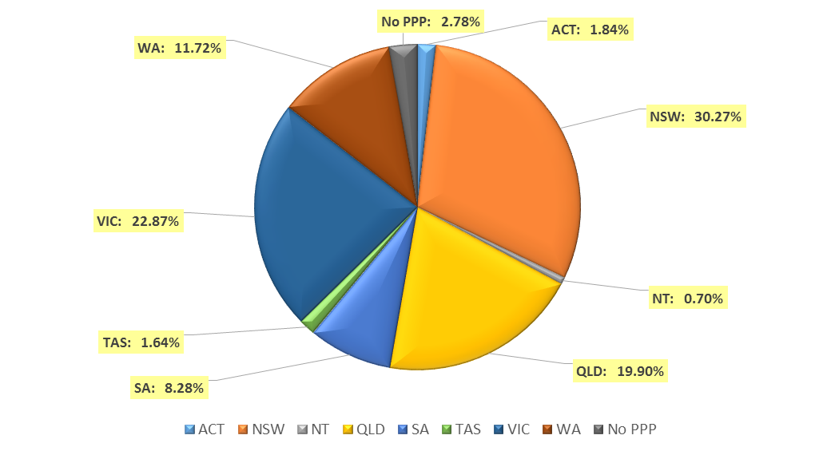

- Registration divisions
  - Dental practitioners - division(s) by state or territory
Divisions | ACT | NSW | NT | QLD | SA | TAS | VIC | WA | No PPP | Total
Dental Hygienist | 42 | 424 | 12 | 138 | 262 | 18 | 219 | 271 | 28 | 1,414
Dental Hygienist and Dental Prosthetist |  | 2 |  | 1 |  |  |  |  |  | 3
Dental Hygienist and Dental Prosthetist and Dental Therapist |  | 1 |  |  |  |  | 1 |  |  | 2
Dental Hygienist and Dental Therapist | 11 | 65 | 7 | 146 | 61 | 2 | 126 | 54 | 8 | 480
Dental Hygienist and Dental Therapist and Dentist |  |  |  | 2 |  |  |  |  |  | 2
Dental Hygienist and Dental Therapist and Oral Health Therapist |  |  |  | 1 |  |  |  |  |  | 1
Dental Hygienist and Dentist |  | 2 |  | 1 |  |  |  |  |  | 3
Dental Hygienist and Oral Health Therapist |  | 2 |  |  | 1 |  |  | 3 |  | 6
Dental Prosthetist | 16 | 409 | 4 | 271 | 63 | 48 | 351 | 85 | 3 | 1,250
Dental Prosthetist and Dental Therapist |  |  |  |  |  |  | 1 |  |  | 1
Dental Prosthetist and Dentist |  |  |  |  |  |  | 1 |  |  | 1
Dental Therapist | 18 | 212 | 15 | 180 | 85 | 48 | 159 | 289 | 10 | 1,016
Dental Therapist and Dentist |  |  |  |  |  |  | 1 |  |  | 1
Dental Therapist and Oral Health Therapist |  |  |  |  |  |  |  | 4 |  | 4
Dentist | 293 | 5,135 | 106 | 3,225 | 1,174 | 229 | 3,814 | 1,737 | 550 | 16,263
Dentist and Oral Health Therapist |  | 1 |  |  | 1 |  |  |  |  | 2
Oral Health Therapist | 21 | 327 | 9 | 361 | 153 | 11 | 299 | 105 | 5 | 1,291
Total | 401 | 6,580 | 153 | 4,326 | 1,800 | 356 | 4,972 | 2,548 | 604 | 21,740

- Registration type and divisions
  - Dental practitioners – registration type and division by state or territory
Registration Type | Divisions |  | ACT | NSW | NT |  | QLD |  | SA |  | TAS |  | VIC |  | WA |  | No PPP | Total
General | Dental Hygienist |  | 41 | 416 | 11 |  | 137 |  | 255 |  | 18 |  | 215 |  | 261 |  | 21 | 1,375
General | Dental Hygienist and Dental Prosthetist |  |  | 2 |  |  | 1 |  |  |  |  |  |  |  |  |  |  | 3
General | Dental Hygienist and Dental Prosthetist and Dental Therapist |  |  | 1 |  |  |  |  |  |  |  |  | 1 |  |  |  |  | 2
General | Dental Hygienist and Dental Therapist |  | 11 | 63 | 6 |  | 145 |  | 61 |  | 2 |  | 123 |  | 53 |  | 8 | 472
General | Dental Hygienist and Dental Therapist and Dentist |  |  |  |  |  | 2 |  |  |  |  |  |  |  |  |  |  | 2
General | Dental Hygienist and Dental Therapist and Oral Health Therapist |  |  |  |  |  | 1 |  |  |  |  |  |  |  |  |  |  | 1
General | Dental Hygienist and Dentist |  |  | 2 |  |  |  |  |  |  |  |  |  |  |  |  |  | 2
General | Dental Hygienist and Oral Health Therapist |  |  | 2 |  |  |  |  | 1 |  |  |  |  |  | 3 |  |  | 6
General | Dental Prosthetist |  | 16 | 398 | 4 |  | 267 |  | 63 |  | 47 |  | 341 |  | 82 |  | 1 | 1,219
General | Dental Prosthetist and Dental Therapist |  |  |  |  |  |  |  |  |  |  |  | 1 |  |  |  |  | 1
General | Dental Prosthetist and Dentist |  |  |  |  |  |  |  |  |  |  |  | 1 |  |  |  |  | 1
General | Dental Therapist |  | 18 | 201 | 15 |  | 175 |  | 83 |  | 47 |  | 152 |  | 279 |  | 9 | 979
General | Dental Therapist and Dentist |  |  |  |  |  |  |  |  |  |  |  | 1 |  |  |  |  | 1
General | Dental Therapist and Oral Health Therapist |  |  |  |  |  |  |  |  |  |  |  |  |  | 4 |  |  | 4
General | Dentist |  | 249 | 4,533 | 99 |  | 2,837 |  | 983 |  | 202 |  | 3,308 |  | 1,532 |  | 376 | 14,119
General | Dentist and Oral Health Therapist |  |  | 1 |  |  |  |  | 1 |  |  |  |  |  |  |  |  | 2
General | Oral Health Therapist |  | 21 | 324 | 9 |  | 352 |  | 150 |  | 11 |  | 294 |  | 103 |  | 4 | 1,268
Sub Total |  |  | 356 | 5,943 | 144 |  | 3,917 |  | 1,597 |  | 327 |  | 4,437 |  | 2,317 |  | 419 | 19,457
General and Specialist | Dentist |  | 38 | 477 | 4 |  | 319 |  | 144 |  | 25 |  | 402 |  | 173 |  | 50 | 1,632
Specialist | Dentist |  | 1 | 4 | 1 |  | 2 |  | 4 |  |  |  | 8 |  | 4 |  | 6 | 30
Limited | Dental Hygienist |  |  | 1 |  |  |  |  |  |  |  |  |  |  |  |  |  | 1
Limited | Dentist |  | 1 | 15 |  |  | 20 |  | 24 |  |  |  | 9 |  | 2 |  | 1 | 72
Limited | Oral Health Therapist |  |  |  |  |  |  |  |  |  |  |  | 1 |  |  |  |  | 1
Sub Total |  |  | 1 | 16 | 0 |  | 20 |  | 24 |  | 0 |  | 10 |  | 2 |  | 1 | 74
Continued on next page
Registration Type | Divisions | ACT |  | NSW | NT | QLD |  | SA |  | TAS |  | VIC |  | WA |  | No PPP |  | Total
General and Non-practising | Dental Hygienist and Dentist |  |  |  |  |  | 1 |  |  |  |  |  |  |  |  |  |  | 1
Non-practising | Dental Hygienist | 1 |  | 7 | 1 | 1 |  | 7 |  |  |  | 4 |  | 10 |  | 7 |  | 38
Non-practising | Dental Hygienist and Dental Therapist |  |  | 2 | 1 | 1 |  |  |  |  |  | 3 |  | 1 |  |  |  | 8
Non-practising | Dental Prosthetist |  |  | 11 |  | 4 |  |  |  | 1 |  | 10 |  | 3 |  | 2 |  | 31
Non-practising | Dental Therapist |  |  | 11 |  | 5 |  | 2 |  | 1 |  | 7 |  | 10 |  | 1 |  | 37
Non-practising | Dentist | 4 |  | 106 | 2 | 47 |  | 19 |  | 2 |  | 87 |  | 26 |  | 117 |  | 410
Non-practising | Oral Health Therapist |  |  | 3 |  | 9 |  | 3 |  |  |  | 4 |  | 2 |  | 1 |  | 22
Sub Total |  | 5 |  | 140 | 4 | 67 |  | 31 |  | 4 |  | 115 |  | 52 |  | 128 |  | 546
Total |  | 401 |  | 6,580 | 153 | 4,326 |  | 1,800 |  | 356 |  | 4,972 |  | 2,548 |  | 604 |  | 21,740

- Dental specialties
  - Dental practitioners – dental speciality by state or territory
Specialty | ACT | NSW | NT | QLD | SA | TAS | VIC | WA | No PPP | Total
Dento-maxillofacial radiology |  |  |  | 6 |  |  | 1 | 3 |  | 10
Endodontics | 7 | 49 |  | 28 | 15 | 3 | 39 | 16 | 6 | 163
Forensic odontology | 2 | 6 | 1 | 2 | 3 | 2 | 5 | 5 |  | 26
Oral and maxillofacial surgery | 4 | 51 | 2 | 44 | 17 | 5 | 50 | 22 | 7 | 202
Oral medicine |  | 7 |  | 5 |  |  | 12 | 7 | 4 | 35
Oral pathology |  | 7 |  | 4 | 3 |  | 4 | 3 | 3 | 24
Oral surgery |  | 38 |  | 4 |  |  | 7 | 1 | 1 | 51
Orthodontics | 11 | 185 | 3 | 127 | 55 | 13 | 138 | 54 | 19 | 605
Paediatric dentistry | 2 | 36 |  | 22 | 13 |  | 36 | 15 | 6 | 130
Periodontics | 8 | 59 |  | 42 | 16 | 2 | 57 | 32 | 7 | 223
Prosthodontics | 5 | 65 |  | 42 | 22 |  | 54 | 21 | 4 | 213
Public health dentistry (Community dentistry) |  | 3 |  | 1 | 2 |  | 8 | 1 | 1 | 16
Special needs dentistry |  | 2 |  | 4 | 2 |  | 7 |  | 1 | 16
Total | 39 | 508 | 6 | 331 | 148 | 25 | 418 | 180 | 59 | 1,714

- Endorsements
  - Dental practitioners – endorsements by state or territory
Endorsement | ACT | NSW | NT | QLD | SA | TAS | VIC | WA | No PPP | Total
Area of Practice – conscious sedation | 4 | 49 | 2 | 22 | 2 | 2 | 5 | 9 |  | 95

- Age group
  - Dental practitioners – by age group
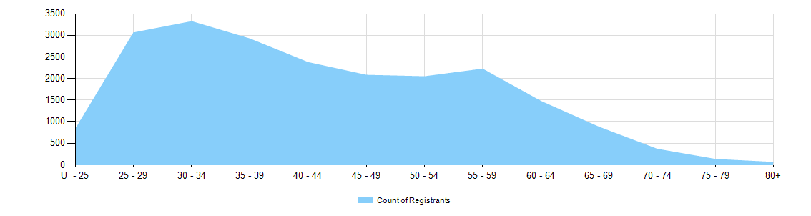
  - Dental practitioners – registration type by age group
Age Group | General | General and Specialist | Specialist | Limited |  |  | Non-practising | Total
 |  |  |  | Postgraduate training or supervised practice | Public interest | Teaching or research | Non-practising | Total
U - 25 | 821 |  |  |  |  |  | 6 | 827
25 - 29 | 2,999 | 5 |  | 9 |  | 1 | 45 | 3,059
30 - 34 | 3,099 | 121 | 5 | 16 |  | 7 | 72 | 3,321
35 - 39 | 2,556 | 279 | 12 | 2 |  | 8 | 62 | 2,919
40 - 44 | 2,099 | 209 | 4 | 1 |  | 11 | 48 | 2,372
45 - 49 | 1,838 | 181 | 7 |  |  | 6 | 46 | 2,078
50 - 54 | 1,788 | 205 | 1 |  | 1 | 7 | 42 | 2,044
55 - 59 | 1,920 | 236 |  |  |  | 2 | 62 | 2,220
60 - 64 | 1,233 | 182 |  |  |  | 2 | 57 | 1,474
65 - 69 | 711 | 121 | 1 |  |  |  | 42 | 875
70 - 74 | 271 | 57 |  |  |  | 1 | 34 | 363
75 - 79 | 90 | 28 |  |  |  |  | 11 | 129
80+ | 32 | 8 |  |  |  |  | 19 | 59
Total | 19,457 | 1,632 | 30 | 28 | 1 | 45 | 546 | 21,740

- Gender
  - Dental practitioners – registration type by gender
Gender | Registration Type | ACT | NSW | NT | QLD | SA | TAS | VIC | WA | No PPP | Total
Female | General | 218 | 2,796 | 77 | 1,952 | 931 | 154 | 2,311 | 1,366 | 186 | 9,991
Female | General and Specialist | 6 | 113 |  | 71 | 40 | 5 | 124 | 45 | 11 | 415
Female | Specialist |  | 2 |  |  | 1 |  | 5 | 2 |  | 10
Female | Limited |  | 11 |  | 7 | 12 |  | 4 | 2 |  | 36
Female | Non-practising | 4 | 67 | 3 | 40 | 17 | 2 | 55 | 34 | 61 | 283
Female | General and Non-practising |  |  |  | 1
Total Female |  | 228 | 2,989 | 80 | 2,071 | 1,001 | 161 | 2,499 | 1,449 | 258 | 10,736
Male | General | 138 | 3,147 | 67 | 1,965 | 666 | 173 | 2,126 | 951 | 233 | 9,466
Male | General and Specialist
Male | Specialist | 1 | 2 | 1 | 2 | 3 |  | 3 | 2 | 6 | 20
Male | Limited | 1 | 5 |  | 13 | 12 |  | 6 |  | 1 | 38
Male | Non-practising | 1 | 73 | 1 | 27 | 14 | 2 | 60 | 18 | 67 | 263
Total Male |  | 173 | 3,591 | 73 | 2,255 | 799 | 195 | 2,473 | 1,099 | 346 | 11,004
Total |  | 401 | 6,580 | 153 | 4,326 | 1,800 | 356 | 4,972 | 2,548 | 604 | 21,740

  - Dental practitioners – percentage by gender
Gender | ACT | NSW | NT | QLD | SA | TAS | VIC | WA | No PPP | Total
Female | 56.9% | 45.4% | 52.3% | 47.9% | 55.6% | 45.2% | 50.3% | 56.9% | 42.7% | 49.4%
Male | 43.1% | 54.6% | 47.7% | 52.1% | 44.4% | 54.8% | 49.7% | 43.1% | 57.3% | 50.6%

