

Dental Board of Australia

Registrant Data

Reporting period: 1 April 2017 – 30 June 2017

Table of contents

1. Registration type 4
2. Registration divisions 5
3. Registration type and divisions 6
5. Dental specialties 8
6. Endorsements 8
7. Age group 9
8. Gender 10

Introduction
The functions of the Dental Board of Australia (the Board) include:
- registering dentists, students, dental specialists, dental therapists, dental hygienists, oral health therapists and dental prosthetists
- developing standards, codes and guidelines for the dental profession
- handling notifications, complaints, investigations and disciplinary hearings
- overseeing the assessment of overseas trained practitioners who wish to practise in Australia, and
- approving accreditation standards and accredited courses of study.
The Board’s functions are supported by the Australian Health Practitioner Regulation Agency (AHPRA). For information about legislation governing our operations see AHPRA's Legislation & Publications at www.ahpra.gov.au/Publications
The Board has analysed its registration data and produced a number of statistical breakdowns about registrants to share with the profession and community. The Board shares these breakdowns regularly.
For more information on dental registration, please see the Board’s website: www.dentalboard.gov.au/Registration.aspx

- Registration type
  - Dental practitioners – registration type by state or territory
Registration Type | Registration Sub-type | ACT | NSW | NT | QLD | SA | TAS | VIC | WA | No PPP | Total
General |  | 362 | 6,121 | 148 | 4,073 | 1,649 | 338 | 4,580 | 2,366 | 416 | 20,053
General and Specialist |  | 41 | 479 | 4 | 320 | 142 | 27 | 415 | 184 | 43 | 1,655
General and Non-practising |  |  |  |  | 1 |  |  |  |  |  | 1
Specialist |  | 2 | 6 |  | 4 | 4 |  | 11 | 5 | 8 | 40
Limited | Postgraduate training or supervised practice |  | 3 |  | 1 | 6 |  | 6 | 1 |  | 17
Limited | Public interest |  |  |  |  |  |  |  |  | 1 | 1
Limited | Teaching or research |  | 12 |  | 17 | 6 |  | 4 | 1 |  | 40
Non-practising |  | 6 | 144 | 4 | 62 | 33 | 6 | 123 | 51 | 147 | 576
Total |  | 411 | 6,765 | 156 | 4,478 | 1,840 | 371 | 5,139 | 2,608 | 615 | 22,383

  - Dental practitioners – percentage by principal place of practice
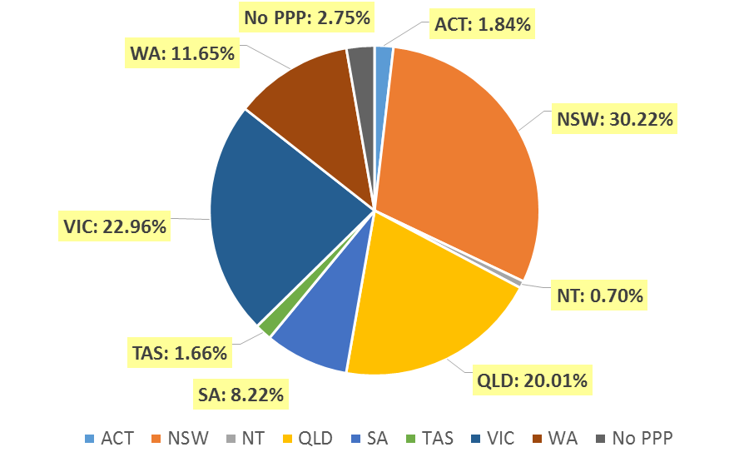

- Registration divisions
  - Dental practitioners – division(s) by state or territory
Divisions | ACT | NSW | NT | QLD | SA | TAS | VIC | WA | No PPP | Total
Dental Hygienist | 42 | 443 | 11 | 143 | 266 | 19 | 218 | 268 | 29 | 1,439
Dental Hygienist and Dental Prosthetist |  | 2 |  | 1 |  |  |  |  |  | 3
Dental Hygienist and Dental Prosthetist and Dental Therapist |  | 1 |  |  |  |  | 1 |  |  | 2
Dental Hygienist and Dental Therapist | 9 | 66 | 7 | 139 | 62 | 2 | 127 | 56 | 4 | 472
Dental Hygienist and Dental Therapist and Dentist |  |  |  | 2 |  |  |  |  |  | 2
Dental Hygienist and Dental Therapist and Oral Health Therapist |  |  |  | 3 |  |  |  |  |  | 3
Dental Hygienist and Dentist |  | 2 |  | 1 |  |  | 1 |  |  | 4
Dental Hygienist and Oral Health Therapist |  | 2 |  |  | 1 |  |  | 5 |  | 8
Dental Prosthetist | 14 | 411 | 6 | 270 | 72 | 49 | 354 | 90 | 5 | 1,271
Dental Prosthetist and Dental Therapist |  |  |  |  |  |  | 1 |  |  | 1
Dental Prosthetist and Dentist |  |  |  |  |  |  | 2 |  |  | 2
Dental Therapist | 18 | 199 | 16 | 173 | 81 | 47 | 149 | 277 | 5 | 965
Dental Therapist and Dentist |  |  |  |  |  |  | 1 |  |  | 1
Dental Therapist and Oral Health Therapist |  |  |  |  |  |  |  | 6 |  | 6
Dentist | 309 | 5,260 | 102 | 3,360 | 1,178 | 243 | 3,936 | 1,777 | 567 | 16,732
Dentist and Oral Health Therapist |  | 1 |  | 1 |  |  |  |  |  | 2
Oral Health Therapist | 19 | 378 | 14 | 385 | 180 | 11 | 349 | 129 | 5 | 1,470
Total | 411 | 6,765 | 156 | 4,478 | 1,840 | 371 | 5,139 | 2,608 | 615 | 22,383

- Registration type and divisions
  - Dental practitioners – registration type and division by state or territory
Registration Type | Divisions | ACT | NSW | NT | QLD | SA | TAS | VIC | WA | No PPP | Total
General | Dental Hygienist | 42 | 433 | 10 | 141 | 262 | 19 | 215 | 257 | 20 | 1,399
General | Dental Hygienist and Dental Prosthetist |  | 2 |  | 1 |  |  |  |  |  | 3
General | Dental Hygienist and Dental Prosthetist and Dental Therapist |  | 1 |  |  |  |  | 1 |  |  | 2
General | Dental Hygienist and Dental Therapist | 9 | 63 | 6 | 138 | 62 | 2 | 123 | 55 | 4 | 462
General | Dental Hygienist and Dental Therapist and Dentist |  |  |  | 2 |  |  |  |  |  | 2
General | Dental Hygienist and Dental Therapist and Oral Health Therapist |  |  |  | 3 |  |  |  |  |  | 3
General | Dental Hygienist and Dentist |  | 2 |  |  |  |  | 1 |  |  | 3
General | Dental Hygienist and Oral Health Therapist |  | 2 |  |  | 1 |  |  | 5 |  | 8
General | Dental Prosthetist | 12 | 398 | 6 | 266 | 71 | 48 | 345 | 87 | 3 | 1,236
General | Dental Prosthetist and Dental Therapist |  |  |  |  |  |  | 1 |  |  | 1
General | Dental Prosthetist and Dentist |  |  |  |  |  |  | 2 |  |  | 2
General | Dental Therapist | 18 | 188 | 16 | 170 | 79 | 46 | 138 | 268 | 4 | 927
General | Dental Therapist and Dentist |  |  |  |  |  |  | 1 |  |  | 1
General | Dental Therapist and Oral Health Therapist |  |  |  |  |  |  |  | 6 |  | 6
General | Dentist | 263 | 4,658 | 96 | 2,972 | 998 | 212 | 3,408 | 1,560 | 382 | 14,549
General | Dentist and Oral Health Therapist |  | 1 |  | 1 |  |  |  |  |  | 2
General | Oral Health Therapist | 18 | 373 | 14 | 379 | 176 | 11 | 345 | 128 | 3 | 1,447
Sub Total |  | 362 | 6,121 | 148 | 4,073 | 1,649 | 338 | 4,580 | 2,366 | 416 | 20,053
General and Specialist | Dentist | 41 | 479 | 4 | 320 | 142 | 27 | 415 | 184 | 43 | 1,655
Specialist | Dentist | 2 | 6 |  | 4 | 4 |  | 11 | 5 | 8 | 40
Limited | Dental Hygienist |  | 1 |  |  |  |  |  |  |  | 1
Limited | Dentist |  | 14 |  | 18 | 12 |  | 9 | 2 | 1 | 56
Limited | Oral Health Therapist |  |  |  |  |  |  | 1 |  |  | 1
Sub Total |  |  | 15 |  | 18 | 12 |  | 10 | 2 | 1 | 58
Continued on next page

Registration Type | Divisions | ACT | NSW | NT | QLD | SA | TAS | VIC | WA | No PPP | Total
General and Non-practising | Dental Hygienist and Dentist |  |  |  | 1 |  |  |  |  |  | 1
Non-practising | Dental Hygienist |  | 9 | 1 | 2 | 4 |  | 3 | 11 | 9 | 39
Non-practising | Dental Hygienist and Dental Therapist |  | 3 | 1 | 1 |  |  | 4 | 1 |  | 10
Non-practising | Dental Prosthetist | 2 | 13 |  | 4 | 1 | 1 | 9 | 3 | 2 | 35
Non-practising | Dental Therapist |  | 11 |  | 3 | 2 | 1 | 11 | 9 | 1 | 38
Non-practising | Dentist | 3 | 103 | 2 | 46 | 22 | 4 | 93 | 26 | 133 | 432
Non-practising | Oral Health Therapist | 1 | 5 |  | 6 | 4 |  | 3 | 1 | 2 | 22
Sub Total |  | 6 | 144 | 4 | 62 | 33 | 6 | 123 | 51 | 147 | 576
Total |  | 411 | 6,765 | 156 | 4,478 | 1,840 | 371 | 5,139 | 2,608 | 615 | 22,383

- Dental specialties
  - Dental practitioners – dental speciality by state or territory
Specialty | ACT | NSW | NT | QLD | SA | TAS | VIC | WA | No PPP | Total
Dento-maxillofacial radiology |  |  |  | 6 |  |  | 1 | 3 |  | 10
Endodontics | 8 | 49 | 1 | 29 | 15 | 3 | 42 | 15 | 7 | 169
Forensic odontology | 2 | 5 | 1 | 2 | 2 | 2 | 5 | 6 |  | 25
Oral and maxillofacial surgery | 3 | 55 | 1 | 47 | 16 | 5 | 55 | 23 | 6 | 211
Oral medicine |  | 8 |  | 5 |  |  | 11 | 8 | 3 | 35
Oral pathology |  | 7 |  | 4 | 3 |  | 3 | 4 | 2 | 23
Oral surgery |  | 37 |  | 4 |  |  | 7 | 2 | 1 | 51
Orthodontics | 13 | 181 | 2 | 127 | 54 | 12 | 141 | 63 | 19 | 612
Paediatric dentistry | 2 | 38 |  | 24 | 13 | 1 | 38 | 15 | 3 | 134
Periodontics | 10 | 61 |  | 39 | 16 | 4 | 59 | 32 | 5 | 226
Prosthodontics | 5 | 65 |  | 42 | 23 |  | 55 | 21 | 5 | 216
Public health dentistry (Community dentistry) |  | 3 |  | 1 | 2 |  | 8 | 1 | 1 | 16
Special needs dentistry |  | 2 |  | 4 | 2 |  | 8 |  | 1 | 17
Total | 43 | 511 | 5 | 334 | 146 | 27 | 433 | 193 | 53 | 1,745

- Endorsements
  - Dental practitioners – endorsements by state or territory
Endorsement | ACT | NSW | NT | QLD | SA | TAS | VIC | WA | No PPP | Total
Area of Practice – conscious sedation | 4 | 50 | 2 | 21 | 2 | 2 | 5 | 10 |  | 96

- Age group
  - Dental practitioners – by age group
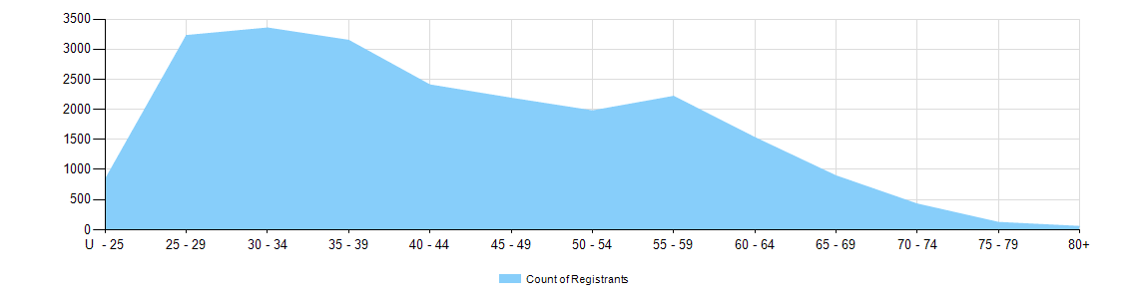

  - Dental practitioners – registration type by age group
Age Group | General | General and Specialist | Specialist | Limited |  |  | General and Non-practising | Non-practising | Total
 |  |  |  | Postgraduate training or supervised practice | Public interest | Teaching or research | General and Non-practising | Non-practising | Total
U - 25 | 834 |  |  |  |  |  |  | 3 | 837
25 - 29 | 3,159 | 14 | 1 | 8 |  | 1 |  | 44 | 3,227
30 - 34 | 3,147 | 105 | 4 | 8 |  | 5 | 1 | 83 | 3,353
35 - 39 | 2,776 | 289 | 15 |  |  | 10 |  | 58 | 3,148
40 - 44 | 2,139 | 210 | 8 | 1 |  | 7 |  | 42 | 2,407
45 - 49 | 1,932 | 192 | 6 |  |  | 6 |  | 50 | 2,186
50 - 54 | 1,726 | 195 | 3 |  |  | 6 |  | 46 | 1,976
55 - 59 | 1,917 | 228 |  |  | 1 | 3 |  | 68 | 2,217
60 - 64 | 1,269 | 198 |  |  |  | 1 |  | 64 | 1,532
65 - 69 | 726 | 118 | 2 |  |  | 1 |  | 48 | 895
70 - 74 | 318 | 70 |  |  |  |  |  | 40 | 428
75 - 79 | 82 | 25 | 1 |  |  |  |  | 14 | 122
80+ | 28 | 11 |  |  |  |  |  | 16 | 55
Total | 20,053 | 1,655 | 40 | 17 | 1 | 40 | 1 | 576 | 22,383

- Gender
  - Dental practitioners – registration type by gender
Gender | Registration Type | ACT | NSW | NT | QLD | SA | TAS | VIC | WA | No PPP | Total
Female | General | 226 | 2,935 | 82 | 2,084 | 965 | 159 | 2,420 | 1,415 | 190 | 10,476
Female | General and Specialist | 7 | 116 | 1 | 72 | 38 | 7 | 132 | 51 | 12 | 436
Female | Specialist | 1 | 2 |  |  | 1 |  | 7 | 2 | 1 | 14
Female | Limited |  | 9 |  | 7 | 7 |  | 3 | 1 |  | 27
Female | Non-practising | 4 | 72 | 2 | 33 | 18 | 3 | 59 | 32 | 67 | 290
Female | General and Non-practising |  |  |  | 1 |  |  |  |  |  | 1
Total Female |  | 238 | 3,134 | 85 | 2,197 | 1,029 | 169 | 2,621 | 1,501 | 270 | 11,244
Male | General | 136 | 3,186 | 66 | 1,989 | 684 | 179 | 2,160 | 951 | 226 | 9,577
Male | General and Specialist | 34 | 363 | 3 | 248 | 104 | 20 | 283 | 133 | 31 | 1,219
Male | Specialist | 1 | 4 |  | 4 | 3 |  | 4 | 3 | 7 | 26
Male | Limited |  | 6 |  | 11 | 5 |  | 7 | 1 | 1 | 31
Male | Non-practising | 2 | 72 | 2 | 29 | 15 | 3 | 64 | 19 | 80 | 286
Total Male |  | 173 | 3,631 | 71 | 2,281 | 811 | 202 | 2,518 | 1,107 | 345 | 11,139
Total |  | 411 | 6,765 | 156 | 4,478 | 1,840 | 371 | 5,139 | 2,608 | 615 | 22,383

  - Dental practitioners – percentage by gender
Gender | ACT | NSW | NT | QLD | SA | TAS | VIC | WA | No PPP | Total
Female | 57.9% | 46.3% | 54.5% | 49.1% | 55.9% | 45.6% | 51.0% | 57.6% | 43.9% | 50.2%
Male | 42.1% | 53.7% | 45.5% | 50.9% | 44.1% | 54.4% | 49.0% | 42.4% | 56.1% | 49.8%

