

Dental Board of Australia

Registrant data

Reporting period: 1 April 2018 – 30 June 2018

Table of contents
Introduction 3
Registration type 4
Registration divisions 5
Registration type and divisions 6
Dental specialties 8
Endorsements 8
Age group 9
Gender 10

Introduction
The functions of the Dental Board of Australia (the Board) include:
- registering dentists, students, dental specialists, dental therapists, dental hygienists, oral health therapists and dental prosthetists
- developing standards, codes and guidelines for the dental profession
- handling notifications, complaints, investigations and disciplinary hearings
- overseeing the assessment of overseas trained practitioners who wish to practise in Australia, and
- approving accreditation standards and accredited courses of study.
The Board’s functions are supported by the Australian Health Practitioner Regulation Agency (AHPRA). For information about legislation governing our operations see AHPRA's Legislation & Publications at www.ahpra.gov.au/Publications
The Board has analysed its registration data and produced a number of statistical breakdowns about registrants to share with the profession and community. The Board shares these breakdowns regularly.
For more information on dental registration, please see the Board’s website: www.dentalboard.gov.au/Registration.aspx

Registration type
  - Dental practitioners – registration type by state or territory
Registration type | Registration subtype | ACT | NSW | NT | QLD | SA | TAS | VIC | WA | No PPP | Total
General |  | 368 | 6,311 | 161 | 4,196 | 1,698 | 359 | 4,770 | 2,424 | 406 | 20,693
General and non-practising |  |  |  |  | 2 |  |  |  |  |  | 2
General and Specialist |  | 40 | 501 | 4 | 323 | 146 | 25 | 429 | 186 | 45 | 1,699
Limited | Postgraduate training or supervised practice |  | 4 |  | 2 | 2 |  | 5 | 4 |  | 17
Limited | Public interest |  |  |  |  |  |  |  |  | 1 | 1
Limited | Teaching or research |  | 8 |  | 15 | 8 |  | 3 | 1 |  | 35
Non-practising |  | 7 | 149 | 3 | 59 | 37 | 2 | 133 | 56 | 156 | 602
Specialist |  | 1 | 8 |  | 5 | 4 |  | 11 | 7 | 8 | 44
Total |  | 416 | 6,981 | 168 | 4,602 | 1,895 | 386 | 5,351 | 2,678 | 616 | 23,093

  - Dental practitioners – percentage by principal place of practice

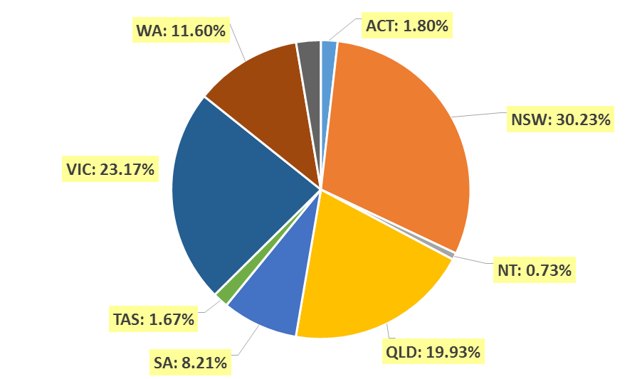

Registration divisions
  - Dental practitioners – division(s) by state or territory
Divisions | ACT | NSW | NT | QLD | SA | TAS | VIC | WA | No PPP | Total
Dental Hygienist | 43 | 421 | 11 | 151 | 283 | 19 | 240 | 267 | 28 | 1,463
Dental Hygienist and Dental Prosthetist |  | 2 |  | 1 |  |  |  |  |  | 3
Dental Hygienist and Dental Prosthetist and Dental Therapist |  | 1 |  |  |  |  | 1 |  |  | 2
Dental Hygienist and Dental Therapist | 8 | 64 | 6 | 136 | 62 | 2 | 130 | 57 | 4 | 469
Dental Hygienist and Dental Therapist and Dentist |  |  |  | 1 |  |  |  |  |  | 1
Dental Hygienist and Dental Therapist and Oral Health Therapist |  | 5 |  | 3 | 5 |  |  |  |  | 13
Dental Hygienist and Dentist |  | 2 |  | 1 |  |  | 1 |  |  | 4
Dental Hygienist and Oral Health Therapist |  | 9 |  | 2 | 1 |  |  | 5 |  | 17
Dental Prosthetist | 14 | 404 | 5 | 269 | 71 | 47 | 353 | 89 | 3 | 1,255
Dental Prosthetist and Dental Therapist |  |  |  |  |  |  | 1 |  |  | 1
Dental Prosthetist and Dentist |  |  |  |  |  |  | 4 |  |  | 4
Dental Prosthetist and Oral Health Therapist |  |  | 1 |  |  |  |  |  |  | 1
Dental Therapist | 15 | 191 | 16 | 168 | 77 | 47 | 138 | 275 | 7 | 934
Dental Therapist and Dentist |  |  |  |  |  |  | 1 |  |  | 1
Dental Therapist and Oral Health Therapist |  |  |  |  |  |  |  | 5 |  | 5
Dentist | 312 | 5,431 | 113 | 3,477 | 1,199 | 252 | 4,074 | 1,818 | 564 | 17,240
Dentist and Oral Health Therapist |  | 2 |  | 1 |  | 1 | 1 |  |  | 5
Oral Health Therapist | 24 | 449 | 16 | 392 | 197 | 18 | 407 | 162 | 10 | 1,675
Total | 416 | 6,981 | 168 | 4,602 | 1,895 | 386 | 5,351 | 2,678 | 616 | 23,093

Registration type and divisions
  - Dental practitioners – registration type and division by state or territory
Registration type | Divisions | ACT | NSW | NT | QLD | SA | TAS | VIC | WA | No PPP | Total
General | Dental Hygienist | 42 | 410 | 11 | 148 | 277 | 19 | 236 | 257 | 19 | 1,419
General | Dental Hygienist and Dental Prosthetist |  | 2 |  | 1 |  |  |  |  |  | 3
General | Dental Hygienist and Dental Prosthetist and Dental Therapist |  | 1 |  |  |  |  | 1 |  |  | 2
General | Dental Hygienist and Dental Therapist | 8 | 60 | 5 | 135 | 62 | 2 | 127 | 56 | 4 | 459
General | Dental Hygienist and Dental Therapist and Dentist |  |  |  | 1 |  |  |  |  |  | 1
General | Dental Hygienist and Dental Therapist and Oral Health Therapist |  | 5 |  | 3 | 5 |  |  |  |  | 13
General | Dental Hygienist and Dentist |  | 2 |  |  |  |  | 1 |  |  | 3
General | Dental Hygienist and Oral Health Therapist |  | 9 |  | 1 | 1 |  |  | 5 |  | 16
General | Dental Prosthetist | 13 | 392 | 5 | 266 | 70 | 46 | 343 | 86 | 1 | 1,222
General | Dental Prosthetist and Dental Therapist |  |  |  |  |  |  | 1 |  |  | 1
General | Dental Prosthetist and Dentist |  |  |  |  |  |  | 4 |  |  | 4
General | Dental Prosthetist and Oral Health Therapist |  |  | 1 |  |  |  |  |  |  | 1
General | Dental Therapist | 15 | 178 | 16 | 164 | 76 | 46 | 129 | 265 | 4 | 893
General | Dental Therapist and Dentist |  |  |  |  |  |  | 1 |  |  | 1
General | Dental Therapist and Oral Health Therapist |  |  |  |  |  |  |  | 5 |  | 5
General | Dentist | 267 | 4,806 | 107 | 3,087 | 1,013 | 227 | 3,525 | 1,589 | 371 | 14,992
General | Dentist and Oral Health Therapist |  | 2 |  | 1 |  | 1 | 1 |  |  | 5
General | Oral Health Therapist | 23 | 444 | 16 | 389 | 194 | 18 | 401 | 161 | 7 | 1,653
Subtotal - General |  | 368 | 6,311 | 161 | 4,196 | 1,698 | 359 | 4,770 | 2,424 | 406 | 20,693
Continued on next page.
Registration Type | Divisions | ACT |  | NSW | NT | QLD | SA | TAS | VIC | WA | No PPP | Total
General and Limited | Dental Hygienist and Dentist
General and Non-practising | Dental Hygienist and Dentist |  |  |  |  | 1 |  |  |  |  |  | 1
General and Non-practising | Dental Hygienist and Oral Health Therapist |  |  |  |  | 1 |  |  |  |  |  | 1
Subtotal – General and non-practicing |  |  |  |  |  | 2 |  |  |  |  |  | 2
General and Specialist | Dentist | 40 |  | 501 | 4 | 323 | 146 | 25 | 429 | 186 | 45 | 1,699
Limited | Dental Hygienist |  |  | 1 |  |  |  |  |  |  |  | 1
Limited | Dentist |  |  | 11 |  | 17 | 10 |  | 7 | 5 | 1 | 51
Limited | Oral Health Therapist |  |  |  |  |  |  |  | 1 |  |  | 1
Subtotal - Limited |  |  |  | 12 |  | 17 | 10 |  | 8 | 5 | 1 | 53
Non-practising | Dental Hygienist | 1 |  | 10 |  | 3 | 6 |  | 4 | 10 | 9 | 43
Non-practising | Dental Hygienist and Dental Therapist |  |  | 4 | 1 | 1 |  |  | 3 | 1 |  | 10
Non-practising | Dental Prosthetist | 1 |  | 12 |  | 3 | 1 | 1 | 10 | 3 | 2 | 33
Non-practising | Dental Therapist |  |  | 13 |  | 4 | 1 | 1 | 9 | 10 | 3 | 41
Non-practising | Dentist | 4 |  | 105 | 2 | 45 | 26 |  | 102 | 31 | 139 | 454
Non-practising | Oral Health Therapist | 1 |  | 5 |  | 3 | 3 |  | 5 | 1 | 3 | 21
Subtotal - Non-practising |  |  | 7 | 149 | 3 | 59 | 37 | 2 | 133 | 56 | 156 | 602
Specialist | Dentist |  | 1 | 8 |  | 5 | 4 |  | 11 | 7 | 8 | 44
Total |  | 416 |  | 6,981 | 168 | 4,602 | 1,895 | 386 | 5,351 | 2,678 | 616 | 23,093

Dental specialties
  - Dental practitioners – dental speciality by state or territory
Specialty | ACT | NSW | NT | QLD | SA | TAS | VIC | WA | No PPP | Total
Dento-maxillofacial radiology |  |  |  | 7 |  |  | 1 | 3 |  | 11
Endodontics | 7 | 50 | 1 | 32 | 16 | 3 | 43 | 15 | 6 | 173
Forensic odontology | 2 | 5 | 1 | 2 | 2 | 2 | 4 | 6 |  | 24
Oral and maxillofacial surgery | 3 | 60 | 1 | 44 | 17 | 5 | 59 | 24 | 8 | 221
Oral medicine |  | 9 |  | 5 |  |  | 10 | 9 | 2 | 35
Oral pathology |  | 8 |  | 4 | 3 |  | 3 | 4 | 1 | 23
Oral surgery |  | 35 |  | 4 |  |  | 7 | 2 | 1 | 49
Orthodontics | 14 | 186 | 2 | 127 | 54 | 10 | 146 | 62 | 16 | 617
Paediatric dentistry | 2 | 43 |  | 25 | 14 | 1 | 42 | 18 | 4 | 149
Periodontics | 8 | 62 |  | 40 | 16 | 4 | 61 | 33 | 8 | 232
Prosthodontics | 5 | 73 |  | 43 | 24 |  | 55 | 19 | 6 | 225
Public health dentistry (Community dentistry) |  | 3 |  | 1 | 2 |  | 8 | 1 | 1 | 16
Special needs dentistry |  | 2 |  | 4 | 2 |  | 8 | 1 | 1 | 18
Total | 41 | 536 | 5 | 338 | 150 | 25 | 447 | 197 | 54 | 1,793

Endorsements
  - Dental practitioners – endorsements by state or territory
Endorsement | ACT | NSW | NT | QLD | SA | TAS | VIC | WA | No PPP | Total
Area of Practice – conscious sedation | 4 | 49 | 1 | 21 | 2 | 2 | 7 | 11 | 1 | 98

Age group
  - Dental practitioners – by age group

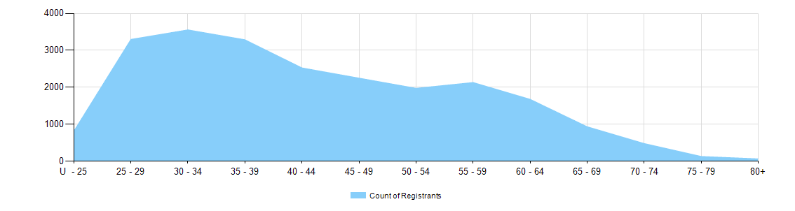

  - Dental practitioners – registration type by age group
Age group | General | General and Specialist | Specialist | Limited |  |  | General and non-practising | Non-practising | Total
 |  |  |  | Postgraduate training or supervised practice | Public interest | Teaching or research | General and non-practising | Non-practising | Total
U - 25 | 555 |  |  |  |  |  |  | 1 | 556
25 - 29 | 3,100 | 10 |  | 5 |  |  |  | 33 | 3,147
30 - 34 | 3,408 | 98 | 3 | 6 |  | 2 | 1 | 79 | 3,598
35 - 39 | 3,004 | 264 | 16 | 5 |  | 9 |  | 65 | 3,361
40 - 44 | 2,265 | 252 | 11 |  |  | 8 |  | 50 | 2,588
45 - 49 | 2,001 | 203 | 4 | 1 |  | 6 | 1 | 48 | 2,263
50 - 54 | 1,736 | 188 | 7 |  |  | 4 |  | 54 | 1,990
55 - 59 | 1,809 | 225 |  |  | 1 | 4 |  | 68 | 2,107
60 - 64 | 1,496 | 198 |  |  |  | 1 |  | 66 | 1,761
65 - 69 | 783 | 146 | 2 |  |  | 1 |  | 57 | 989
70 - 74 | 404 | 71 |  |  |  |  |  | 50 | 525
75 - 79 | 99 | 26 | 1 |  |  |  |  | 15 | 141
80+ | 33 | 18 |  |  |  |  |  | 16 | 67
Total | 20,693 | 1,699 | 44 | 17 | 1 | 35 | 2 | 602 | 23,093
Gender
  - Dental practitioners – registration type by gender
Gender | Registration type | ACT | NSW | NT | QLD | SA | TAS | VIC | WA | No PPP | Total
Female | General | 234 | 3,114 | 90 | 2,173 | 1,020 | 176 | 2,567 | 1,452 | 189 | 11,015
Female | General and Specialist | 7 | 128 | 1 | 76 | 39 | 6 | 135 | 55 | 13 | 460
Female | Specialist | 1 | 5 |  |  | 1 |  | 7 | 3 | 1 | 18
Female | Limited | 0 | 6 | 0 | 6 | 6 | 0 | 3 | 3 | 0 | 24
Female | Non-practising | 4 | 74 | 1 | 29 | 18 | 2 | 66 | 32 | 72 | 298
Female | General and Non-practising |  |  |  | 2 |  |  |  |  |  | 2
Total female |  | 246 | 3,327 | 92 | 2,286 | 1,084 | 184 | 2,778 | 1,545 | 275 | 11,817
Male | General | 134 | 3,197 | 71 | 2,023 | 678 | 183 | 2,203 | 972 | 217 | 9,678
Male | General and Specialist | 33 | 373 | 3 | 247 | 107 | 19 | 294 | 131 | 32 | 1,239
Male | Specialist |  | 3 |  | 5 | 3 |  | 4 | 4 | 7 | 26
Male | Limited | 0 | 6 | 0 | 11 | 4 | 0 | 5 | 2 | 0 | 29
Male | Non-practising | 3 | 75 | 2 | 30 | 19 |  | 67 | 24 | 84 | 304
Total male |  | 170 | 3,654 | 76 | 2,316 | 811 | 202 | 2,573 | 1,133 | 341 | 11,276
Total |  | 416 | 6,981 | 168 | 4,602 | 1,895 | 386 | 5,351 | 2,678 | 616 | 23,093

  - Dental practitioners – percentage by gender
Gender | ACT | NSW | NT | QLD | SA | TAS | VIC | WA | No PPP | Total
Female | 59.1% | 47.7% | 54.8% | 49.7% | 57.2% | 47.7% | 51.9% | 57.7% | 44.6% | 51.2%
Male | 40.9% | 52.3% | 45.2% | 50.3% | 42.8% | 52.3% | 48.1% | 42.3% | 55.4% | 48.8%

