

Dental Board of Australia

Registrant data

Reporting period: 1 October 2017 – 31 December 2017

Table of contents
Introduction 3
Registration type 4
Registration divisions 5
Registration type and divisions 6
Dental specialties 8
Endorsements 8
Age group 9
Gender 10

Introduction
The functions of the Dental Board of Australia (the Board) include:
- registering dentists, students, dental specialists, dental therapists, dental hygienists, oral health therapists and dental prosthetists
- developing standards, codes and guidelines for the dental profession
- handling notifications, complaints, investigations and disciplinary hearings
- overseeing the assessment of overseas trained practitioners who wish to practise in Australia, and
- approving accreditation standards and accredited courses of study.
The Board’s functions are supported by the Australian Health Practitioner Regulation Agency (AHPRA). For information about legislation governing our operations see AHPRA's Legislation & Publications at www.ahpra.gov.au/Publications
The Board has analysed its registration data and produced a number of statistical breakdowns about registrants to share with the profession and community. The Board shares these breakdowns regularly.
For more information on dental registration, please see the Board’s website: www.dentalboard.gov.au/Registration.aspx

Registration type
  - Dental practitioners – registration type by state or territory
Registration type | Registration subtype | ACT | NSW | NT | QLD | SA | TAS | VIC | WA | No PPP | Total
General |  | 367 | 6,259 | 155 | 4,189 | 1,663 | 357 | 4,696 | 2,396 | 418 | 20,500
General and non-practising |  |  | 1 |  | 1 |  |  |  |  |  | 2
General and Specialist |  | 40 | 483 | 4 | 321 | 146 | 26 | 414 | 184 | 46 | 1,664
Limited | Postgraduate training or supervised practice |  | 4 |  | 1 | 4 |  | 4 | 3 |  | 16
Limited | Public interest
Limited | Teaching or research |  | 12 |  | 18 | 9 |  | 4 | 1 |  | 44
Non-practising |  | 9 | 159 | 4 | 63 | 41 | 3 | 140 | 61 | 163 | 643
Specialist |  | 1 | 7 |  | 4 | 4 |  | 11 | 5 | 9 | 41
Total |  | 417 | 6,925 | 163 | 4,597 | 1,867 | 386 | 5,269 | 2,650 | 636 | 22,910

  - Dental practitioners – percentage by principal place of practice

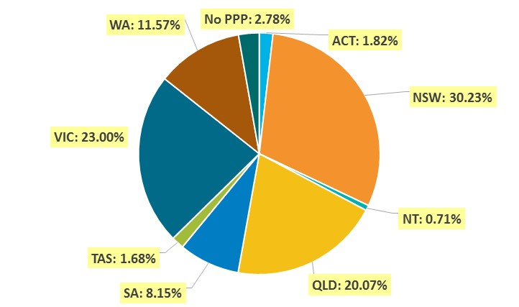

Registration divisions
  - Dental practitioners – division(s) by state or territory
Divisions | ACT | NSW | NT | QLD | SA | TAS | VIC | WA | No PPP | Total
Dental Hygienist | 44 | 436 | 11 | 146 | 274 | 18 | 225 | 272 | 32 | 1,458
Dental Hygienist and Dental Prosthetist |  | 2 |  | 1 |  |  |  |  |  | 3
Dental Hygienist and Dental Prosthetist and Dental Therapist |  | 1 |  |  |  |  | 1 |  |  | 2
Dental Hygienist and Dental Therapist | 8 | 65 | 6 | 140 | 62 | 2 | 131 | 57 | 5 | 476
Dental Hygienist and Dental Therapist and Dentist |  |  |  | 2 |  |  |  |  |  | 2
Dental Hygienist and Dental Therapist and Oral Health Therapist |  | 2 |  | 2 |  |  |  |  |  | 4
Dental Hygienist and Dentist |  | 3 |  | 1 |  |  | 1 |  |  | 5
Dental Hygienist and Oral Health Therapist |  | 3 |  | 1 | 1 |  |  | 5 |  | 10
Dental Prosthetist | 15 | 411 | 5 | 275 | 73 | 50 | 358 | 90 | 4 | 1,281
Dental Prosthetist and Dental Therapist |  |  |  |  |  |  | 1 |  |  | 1
Dental Prosthetist and Dentist |  |  |  |  |  |  | 3 |  |  | 3
Dental Prosthetist and Oral Health Therapist |  |  | 1 |  |  |  |  |  |  | 1
Dental Therapist | 18 | 199 | 17 | 174 | 80 | 48 | 147 | 278 | 6 | 967
Dental Therapist and Dentist |  |  |  |  |  |  | 1 |  |  | 1
Dental Therapist and Oral Health Therapist |  |  |  |  |  |  |  | 6 |  | 6
Dentist | 310 | 5,402 | 108 | 3,456 | 1,197 | 252 | 4,018 | 1,808 | 580 | 17,131
Dentist and Oral Health Therapist |  | 1 | 1 | 3 |  | 1 | 1 |  |  | 7
Oral Health Therapist | 22 | 400 | 14 | 396 | 180 | 15 | 382 | 134 | 9 | 1,552
Total | 417 | 6,925 | 163 | 4,597 | 1,867 | 386 | 5,269 | 2,650 | 636 | 22,910

Registration type and divisions
  - Dental practitioners – registration type and division by state or territory
Registration type | Divisions | ACT | NSW | NT | QLD | SA | TAS | VIC | WA | No PPP | Total
General | Dental Hygienist | 43 | 426 | 10 | 143 | 268 | 18 | 221 | 261 | 23 | 1,413
General | Dental Hygienist and Dental Prosthetist |  | 2 |  | 1 |  |  |  |  |  | 3
General | Dental Hygienist and Dental Prosthetist and Dental Therapist |  | 1 |  |  |  |  | 1 |  |  | 2
General | Dental Hygienist and Dental Therapist | 8 | 61 | 5 | 139 | 62 | 2 | 128 | 56 | 5 | 466
General | Dental Hygienist and Dental Therapist and Dentist |  |  |  | 2 |  |  |  |  |  | 2
General | Dental Hygienist and Dental Therapist and Oral Health Therapist |  | 2 |  | 2 |  |  |  |  |  | 4
General | Dental Hygienist and Dentist |  | 3 |  |  |  |  | 1 |  |  | 4
General | Dental Hygienist and Oral Health Therapist |  | 2 |  | 1 | 1 |  |  | 5 |  | 9
General | Dental Prosthetist | 13 | 397 | 5 | 272 | 72 | 49 | 346 | 87 | 2 | 1,243
General | Dental Prosthetist and Dental Therapist |  |  |  |  |  |  | 1 |  |  | 1
General | Dental Prosthetist and Dentist |  |  |  |  |  |  | 3 |  |  | 3
General | Dental Prosthetist and Oral Health Therapist |  |  | 1 |  |  |  |  |  |  | 1
General | Dental Therapist | 18 | 187 | 17 | 170 | 79 | 47 | 137 | 267 | 4 | 926
General | Dental Therapist and Dentist |  |  |  |  |  |  | 1 |  |  | 1
General | Dental Therapist and Oral Health Therapist |  |  |  |  |  |  |  | 6 |  | 6
General | Dentist | 264 | 4,782 | 102 | 3,064 | 1,005 | 225 | 3,480 | 1,581 | 378 | 14,881
General | Dentist and Oral Health Therapist |  | 1 | 1 | 3 |  | 1 | 1 |  |  | 7
General | Oral Health Therapist | 21 | 395 | 14 | 392 | 176 | 15 | 376 | 133 | 6 | 1,528
Subtotal - General |  | 367 | 6,259 | 155 | 4,189 | 1,663 | 357 | 4,696 | 2,396 | 418 | 20,500
Continued on next page.
Registration Type | Divisions | ACT |  | NSW | NT | QLD | SA | TAS | VIC | WA | No PPP | Total
General and Limited | Dental Hygienist and Dentist
General and Non-practising | Dental Hygienist and Dentist |  |  |  |  | 1 |  |  |  |  |  | 1
General and Non-practising | Dental Hygienist and Oral Health Therapist |  |  | 1 |  |  |  |  |  |  |  | 1
Subtotal – General and non-practicing |  |  |  | 1 |  | 1 |  |  |  |  |  | 2
General and Specialist | Dentist | 40 |  | 483 | 4 | 321 | 146 | 26 | 414 | 184 | 46 | 1,664
Limited | Dental Hygienist |  |  | 1 |  |  |  |  |  |  |  | 1
Limited | Dentist |  |  | 15 |  | 19 | 13 |  | 7 | 4 |  | 58
Limited | Oral Health Therapist |  |  |  |  |  |  |  | 1 |  |  | 1
Subtotal - Limited |  |  |  | 16 |  | 19 | 13 |  | 8 | 4 |  | 60
Non-practising | Dental Hygienist | 1 |  | 9 | 1 | 3 | 6 |  | 4 | 11 | 9 | 44
Non-practising | Dental Hygienist and Dental Therapist |  |  | 4 | 1 | 1 |  |  | 3 | 1 |  | 10
Non-practising | Dental Prosthetist | 2 |  | 14 |  | 3 | 1 | 1 | 12 | 3 | 2 | 38
Non-practising | Dental Therapist |  |  | 12 |  | 4 | 1 | 1 | 10 | 11 | 2 | 41
Non-practising | Dentist | 5 |  | 115 | 2 | 48 | 29 | 1 | 106 | 34 | 147 | 487
Non-practising | Oral Health Therapist | 1 |  | 5 |  | 4 | 4 |  | 5 | 1 | 3 | 23
Subtotal – Non-practising |  |  | 9 | 160 | 4 | 64 | 41 | 3 | 140 | 61 | 163 | 645
Specialist | Dentist |  | 1 | 7 |  | 4 | 4 |  | 11 | 5 | 9 | 41
Total |  | 417 |  | 6,925 | 163 | 4,597 | 1,867 | 386 | 5,269 | 2,650 | 636 | 22,910

Dental specialties
  - Dental practitioners – dental speciality by state or territory
Specialty | ACT | NSW | NT | QLD | SA | TAS | VIC | WA | No PPP | Total
Dento-maxillofacial radiology |  |  |  | 7 |  |  | 1 | 3 |  | 11
Endodontics | 8 | 49 | 1 | 31 | 15 | 3 | 42 | 14 | 7 | 170
Forensic odontology | 2 | 5 | 1 | 2 | 2 | 2 | 5 | 6 |  | 25
Oral and maxillofacial surgery | 3 | 56 | 1 | 44 | 17 | 5 | 55 | 23 | 10 | 214
Oral medicine |  | 9 |  | 5 |  |  | 11 | 8 | 2 | 35
Oral pathology |  | 8 |  | 4 | 3 |  | 3 | 4 | 1 | 23
Oral surgery |  | 37 |  | 4 |  |  | 7 | 2 | 1 | 51
Orthodontics | 13 | 184 | 2 | 127 | 54 | 11 | 141 | 63 | 17 | 612
Paediatric dentistry | 2 | 38 |  | 23 | 15 | 1 | 38 | 17 | 3 | 137
Periodontics | 8 | 59 |  | 41 | 16 | 4 | 59 | 32 | 7 | 226
Prosthodontics | 5 | 67 |  | 42 | 24 |  | 54 | 20 | 6 | 218
Public health dentistry (Community dentistry) |  | 3 |  | 1 | 2 |  | 8 | 1 | 1 | 16
Special needs dentistry |  | 2 |  | 4 | 2 |  | 8 |  | 1 | 17
Total | 41 | 517 | 5 | 335 | 150 | 26 | 432 | 193 | 56 | 1,755

Endorsements
  - Dental practitioners – endorsements by state or territory
Endorsement | ACT | NSW | NT | QLD | SA | TAS | VIC | WA | No PPP | Total
Area of Practice – conscious sedation | 4 | 49 | 1 | 21 | 2 | 2 | 7 | 10 |  | 96

Age group
  - Dental practitioners – by age group
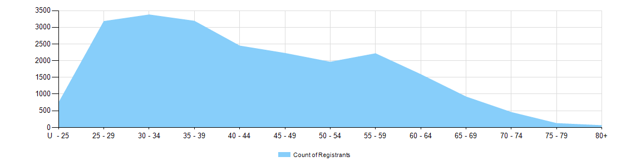

  - Dental practitioners – registration type by age group
Age group | General | General and Specialist | Specialist | Limited |  |  | General and non-practising | Non-practising | Total
 |  |  |  | Postgraduate training or supervised practice | Public interest | Teaching or research | General and non-practising | Non-practising | Total
U - 25 | 815 |  |  |  |  |  |  | 1 | 816
25 - 29 | 3,227 | 12 | 1 | 5 |  |  | 1 | 48 | 3,294
30 - 34 | 3,235 | 98 | 5 | 7 |  | 5 | 1 | 93 | 3,444
35 - 39 | 2,840 | 282 | 13 | 3 |  | 11 |  | 63 | 3,212
40 - 44 | 2,196 | 217 | 10 | 1 |  | 9 |  | 51 | 2,484
45 - 49 | 1,986 | 205 | 5 |  |  | 6 |  | 46 | 2,248
50 - 54 | 1,706 | 195 | 4 |  |  | 6 |  | 60 | 1,971
55 - 59 | 1,875 | 218 |  |  |  | 3 |  | 71 | 2,167
60 - 64 | 1,384 | 199 |  |  |  | 3 |  | 76 | 1,662
65 - 69 | 759 | 127 | 2 |  |  | 1 |  | 57 | 946
70 - 74 | 358 | 74 |  |  |  |  |  | 43 | 475
75 - 79 | 88 | 23 | 1 |  |  |  |  | 17 | 129
80+ | 31 | 14 |  |  |  |  |  | 17 | 62
Total | 20,500 | 1,664 | 41 | 16 |  | 44 | 2 | 643 | 22,910
Gender
  - Dental practitioners – registration type by gender
Gender | Registration type | ACT | NSW | NT | QLD | SA | TAS | VIC | WA | No PPP | Total
Female | General | 232 | 3,035 | 85 | 2,151 | 982 | 172 | 2,496 | 1,425 | 194 | 10,772
Female | General and Specialist | 7 | 119 | 1 | 74 | 39 | 7 | 132 | 53 | 12 | 444
Female | Specialist | 1 | 3 |  |  | 1 |  | 7 | 2 | 1 | 15
Female | Limited |  | 8 |  | 7 | 7 |  | 2 | 2 |  | 26
Female | Non-practising | 5 | 78 | 2 | 32 | 20 | 2 | 69 | 37 | 74 | 319
Female | General and Non-practising |  | 1 |  | 1 |  |  |  |  |  | 2
Total female |  | 245 | 3,244 | 88 | 2,265 | 1049 | 181 | 2,706 | 1,519 | 281 | 11,578
Male | General | 135 | 3,224 | 70 | 2,038 | 681 | 185 | 2,200 | 971 | 224 | 9,728
Male | General and Specialist | 33 | 364 | 3 | 247 | 107 | 19 | 282 | 131 | 34 | 1,220
Male | Specialist |  | 4 |  | 4 | 3 |  | 4 | 3 | 8 | 26
Male | Limited |  | 8 |  | 12 | 6 |  | 6 | 2 |  | 34
Male | Non-practising | 4 | 81 | 2 | 31 | 21 | 1 | 71 | 24 | 89 | 324
Total male |  | 172 | 3681 | 75 | 2332 | 818 | 205 | 2563 | 1131 | 355 | 11,332
Total |  | 417 | 6925 | 163 | 4597 | 1867 | 386 | 5269 | 2650 | 636 | 22,910

  - Dental practitioners – percentage by gender
Gender | ACT | NSW | NT | QLD | SA | TAS | VIC | WA | No PPP | Total
Female | 58.8% | 46.8% | 54.0% | 49.3% | 56.2% | 46.9% | 51.4% | 57.3% | 44.2% | 50.5%
Male | 41.2% | 53.2% | 46.0% | 50.7% | 43.8% | 53.1% | 48.6% | 42.7% | 55.8% | 49.5%

