

Dental Board of Australia

Registrant data

Reporting period: 1 July 2018 – 30 September 2018

Table of contents
Introduction 3
Registration type 4
Registration divisions 5
Registration type and divisions 6
Dental specialties 8
Endorsements 8
Age group 9
Gender 10

Introduction
The functions of the Dental Board of Australia (the Board) include:
- registering dentists, students, dental specialists, dental therapists, dental hygienists, oral health therapists and dental prosthetists
- developing standards, codes and guidelines for the dental profession
- handling notifications, complaints, investigations and disciplinary hearings
- overseeing the assessment of overseas trained practitioners who wish to practise in Australia, and
- approving accreditation standards and accredited courses of study.
The Board’s functions are supported by the Australian Health Practitioner Regulation Agency (AHPRA). For information about legislation governing our operations see AHPRA's Legislation & Publications at www.ahpra.gov.au/Publications
The Board has analysed its registration data and produced a number of statistical breakdowns about registrants to share with the profession and community. The Board shares these breakdowns regularly.
For more information on dental registration, please see the Board’s website: www.dentalboard.gov.au/Registration.aspx

Registration type
  - Dental practitioners – registration type by state or territory
Registration type | Registration subtype | ACT | NSW | NT | QLD | SA | TAS | VIC | WA | No PPP | Total
General |  | 372 | 6,322 | 159 | 4,210 | 1,699 | 361 | 4,800 | 2,432 | 409 | 20,764
General and non-practising |  |  |  |  | 2 |  |  |  |  |  | 2
General and Specialist |  | 40 | 500 | 4 | 324 | 147 | 25 | 432 | 188 | 44 | 1,704
Limited | Postgraduate training or supervised practice |  | 4 |  | 2 | 1 |  | 5 | 4 |  | 16
Limited | Public interest
Limited | Teaching or research |  | 7 |  | 16 | 5 |  | 2 | 2 |  | 32
Non-practising |  | 7 | 150 | 3 | 59 | 37 | 2 | 133 | 56 | 156 | 603
Specialist |  | 1 | 8 |  | 5 | 4 |  | 10 | 7 | 9 | 44
Total |  | 420 | 6,991 | 166 | 4,618 | 1,893 | 388 | 5,382 | 2,689 | 618 | 23,165

  - Dental practitioners – percentage by principal place of practice

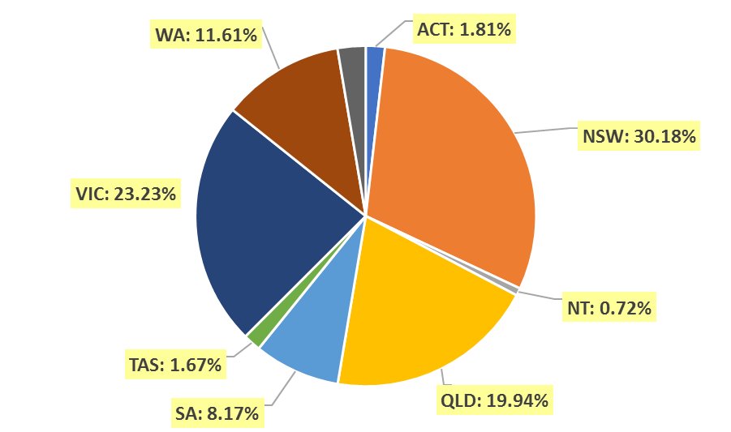

Registration divisions
  - Dental practitioners – division(s) by state or territory
Divisions | ACT | NSW | NT | QLD | SA | TAS | VIC | WA | No PPP | Total
Dental Hygienist | 43 | 420 | 10 | 151 | 283 | 20 | 242 | 269 | 28 | 1,466
Dental Hygienist and Dental Prosthetist |  | 2 |  | 1 |  |  |  |  |  | 3
Dental Hygienist and Dental Prosthetist and Dental Therapist |  | 1 |  |  |  |  | 1 |  |  | 2
Dental Hygienist and Dental Therapist | 8 | 64 | 6 | 136 | 62 | 2 | 130 | 57 | 3 | 468
Dental Hygienist and Dental Therapist and Dentist |  |  |  | 1 |  |  |  |  |  | 1
Dental Hygienist and Dental Therapist and Oral Health Therapist |  | 6 |  | 4 | 5 |  |  |  |  | 15
Dental Hygienist and Dentist |  | 2 |  | 1 |  |  | 1 |  |  | 4
Dental Hygienist and Oral Health Therapist |  | 9 |  | 2 | 1 |  | 2 | 5 |  | 19
Dental Prosthetist | 14 | 409 | 5 | 270 | 71 | 47 | 355 | 89 | 3 | 1,263
Dental Prosthetist and Dental Therapist |  |  |  |  |  |  | 1 |  |  | 1
Dental Prosthetist and Dentist |  |  |  |  |  |  | 4 |  |  | 4
Dental Prosthetist and Oral Health Therapist |  |  | 1 |  |  |  |  |  |  | 1
Dental Therapist | 15 | 192 | 15 | 168 | 77 | 47 | 139 | 275 | 7 | 935
Dental Therapist and Dentist |  |  |  |  |  |  | 1 |  |  | 1
Dental Therapist and Oral Health Therapist |  |  |  |  |  |  |  | 5 |  | 5
Dentist | 313 | 5,435 | 114 | 3,489 | 1,197 | 253 | 4,085 | 1,827 | 567 | 17,280
Dentist and Oral Health Therapist |  | 2 |  | 1 |  | 1 | 1 |  |  | 5
Oral Health Therapist | 27 | 449 | 15 | 394 | 197 | 18 | 420 | 162 | 10 | 1,692
Total | 420 | 6,991 | 166 | 4,618 | 1,893 | 388 | 5,382 | 2,689 | 618 | 23,165

Registration type and divisions
  - Dental practitioners – registration type and division by state or territory
Registration type | Divisions | ACT | NSW | NT | QLD | SA | TAS | VIC | WA | No PPP | Total
General | Dental Hygienist | 42 | 409 | 10 | 148 | 277 | 20 | 238 | 259 | 19 | 1,422
General | Dental Hygienist and Dental Prosthetist |  | 2 |  | 1 |  |  |  |  |  | 3
General | Dental Hygienist and Dental Prosthetist and Dental Therapist |  | 1 |  |  |  |  | 1 |  |  | 2
General | Dental Hygienist and Dental Therapist | 8 | 60 | 5 | 135 | 62 | 2 | 127 | 56 | 3 | 458
General | Dental Hygienist and Dental Therapist and Dentist |  |  |  | 1 |  |  |  |  |  | 1
General | Dental Hygienist and Dental Therapist and Oral Health Therapist |  | 6 |  | 4 | 5 |  |  |  |  | 15
General | Dental Hygienist and Dentist |  | 2 |  |  |  |  | 1 |  |  | 3
General | Dental Hygienist and Oral Health Therapist |  | 9 |  | 1 | 1 |  | 2 | 5 |  | 18
General | Dental Prosthetist | 13 | 397 | 5 | 267 | 70 | 46 | 345 | 86 | 1 | 1,230
General | Dental Prosthetist and Dental Therapist |  |  |  |  |  |  | 1 |  |  | 1
General | Dental Prosthetist and Dentist |  |  |  |  |  |  | 4 |  |  | 4
General | Dental Prosthetist and Oral Health Therapist |  |  | 1 |  |  |  |  |  |  | 1
General | Dental Therapist | 15 | 179 | 15 | 164 | 76 | 46 | 129 | 265 | 4 | 893
General | Dental Therapist and Dentist |  |  |  |  |  |  | 1 |  |  | 1
General | Dental Therapist and Oral Health Therapist |  |  |  |  |  |  |  | 5 |  | 5
General | Dentist | 268 | 4,811 | 108 | 3,097 | 1,014 | 228 | 3,536 | 1,595 | 375 | 15,032
General | Dentist and Oral Health Therapist |  | 2 |  | 1 |  | 1 | 1 |  |  | 5
General | Oral Health Therapist | 26 | 444 | 15 | 391 | 194 | 18 | 414 | 161 | 7 | 1,670
Subtotal - General |  | 372 | 6,322 | 159 | 4,210 | 1,699 | 361 | 4,800 | 2,432 | 409 | 20,764
Continued on next page.
Registration Type | Divisions | ACT |  | NSW | NT | QLD | SA | TAS | VIC | WA | No PPP | Total
General and Limited | Dental Hygienist and Dentist |  |  |  |  |  |  |  |  |  |  | 0
General and Non-practising | Dental Hygienist and Dentist |  |  |  |  | 1 |  |  |  |  |  | 1
General and Non-practising | Dental Hygienist and Oral Health Therapist |  |  |  |  | 1 |  |  |  |  |  | 1
Subtotal – General and non-practicing |  |  |  |  |  | 2 |  |  |  |  |  | 2
General and Specialist | Dentist | 40 |  | 500 | 4 | 324 | 147 | 25 | 432 | 188 | 44 | 1,704
Limited | Dental Hygienist |  |  | 1 |  |  |  |  |  |  |  | 1
Limited | Dentist |  |  | 10 |  | 18 | 6 |  | 6 | 6 |  | 46
Limited | Oral Health Therapist |  |  |  |  |  |  |  | 1 |  |  | 1
Subtotal - Limited |  |  |  | 11 |  | 18 | 6 |  | 7 | 6 |  | 48
Non-practising | Dental Hygienist | 1 |  | 10 |  | 3 | 6 |  | 4 | 10 | 9 | 43
Non-practising | Dental Hygienist and Dental Therapist |  |  | 4 | 1 | 1 |  |  | 3 | 1 |  | 10
Non-practising | Dental Prosthetist | 1 |  | 12 |  | 3 | 1 | 1 | 10 | 3 | 2 | 33
Non-practising | Dental Therapist |  |  | 13 |  | 4 | 1 | 1 | 10 | 10 | 3 | 42
Non-practising | Dentist | 4 |  | 106 | 2 | 45 | 26 |  | 101 | 31 | 139 | 454
Non-practising | Oral Health Therapist | 1 |  | 5 |  | 3 | 3 |  | 5 | 1 | 3 | 21
Subtotal - Non-practising |  |  | 7 | 150 | 3 | 59 | 37 | 2 | 133 | 56 | 156 | 603
Specialist | Dentist |  | 1 | 8 |  | 5 | 4 |  | 10 | 7 | 9 | 44
Total |  | 420 |  | 6,991 | 166 | 4,618 | 1,893 | 388 | 5,382 | 2,689 | 618 | 23,165

Dental specialties
  - Dental practitioners – dental speciality by state or territory
Specialty | ACT | NSW | NT | QLD | SA | TAS | VIC | WA | No PPP | Total
Dento-maxillofacial radiology |  |  |  | 7 |  |  | 1 | 3 |  | 11
Endodontics | 7 | 50 | 1 | 32 | 16 | 3 | 43 | 15 | 6 | 173
Forensic odontology | 2 | 5 | 1 | 2 | 2 | 2 | 4 | 6 |  | 24
Oral and maxillofacial surgery | 3 | 60 | 1 | 44 | 16 | 5 | 60 | 24 | 8 | 221
Oral medicine |  | 9 |  | 5 |  |  | 10 | 9 | 2 | 35
Oral pathology |  | 8 |  | 4 | 3 |  | 3 | 4 | 1 | 23
Oral surgery |  | 35 |  | 5 |  |  | 7 | 2 | 1 | 50
Orthodontics | 14 | 186 | 2 | 127 | 55 | 10 | 147 | 62 | 16 | 619
Paediatric dentistry | 2 | 43 |  | 25 | 14 | 1 | 42 | 19 | 4 | 150
Periodontics | 8 | 62 |  | 40 | 16 | 4 | 62 | 34 | 7 | 233
Prosthodontics | 5 | 72 |  | 43 | 25 |  | 54 | 19 | 7 | 225
Public health dentistry (Community dentistry) |  | 3 |  | 1 | 2 |  | 8 | 1 | 1 | 16
Special needs dentistry |  | 2 |  | 4 | 2 |  | 8 | 1 | 1 | 18
Total | 41 | 535 | 5 | 339 | 151 | 25 | 449 | 199 | 54 | 1,798

Endorsements
  - Dental practitioners – endorsements by state or territory
Endorsement | ACT | NSW | NT | QLD | SA | TAS | VIC | WA | No PPP | Total
Area of Practice – conscious sedation | 4 | 49 | 1 | 21 | 2 | 2 | 7 | 11 | 1 | 98

Age group
  - Dental practitioners – by age group

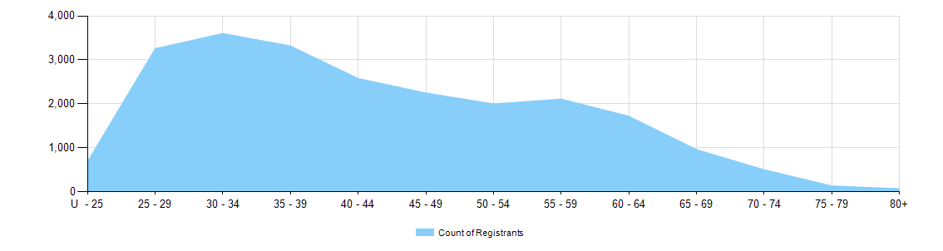

  - Dental practitioners – registration type by age group
Age group | General | General and Specialist | Specialist | Limited |  |  | General and non-practising | Non-practising | Total
 |  |  |  | Postgraduate training or supervised practice | Public interest | Teaching or research | General and non-practising | Non-practising | Total
U - 25 | 689 |  |  |  |  |  |  | 1 | 690
25 - 29 | 3,204 | 12 |  | 4 |  |  |  | 38 | 3,258
30 - 34 | 3,400 | 109 | 3 | 6 |  | 2 | 1 | 81 | 3,602
35 - 39 | 2,958 | 270 | 16 | 4 |  | 7 |  | 62 | 3,317
40 - 44 | 2,258 | 250 | 11 | 1 |  | 8 |  | 48 | 2,576
45 - 49 | 1,987 | 199 | 6 | 1 |  | 5 | 1 | 48 | 2,247
50 - 54 | 1,741 | 189 | 5 |  |  | 5 |  | 58 | 1,998
55 - 59 | 1,807 | 229 |  |  |  | 3 |  | 68 | 2,107
60 - 64 | 1,450 | 198 |  |  |  | 1 |  | 69 | 1,718
65 - 69 | 765 | 138 | 2 |  |  | 1 |  | 51 | 957
70 - 74 | 381 | 68 |  |  |  |  |  | 50 | 499
75 - 79 | 92 | 24 | 1 |  |  |  |  | 13 | 130
80+ | 32 | 18 |  |  |  |  |  | 16 | 66
Total | 20,764 | 1,704 | 44 | 16 | 0 | 32 | 2 | 603 | 23,165
Gender
  - Dental practitioners – registration type by gender
Gender | Registration type | ACT | NSW | NT | QLD | SA | TAS | VIC | WA | No PPP | Total
Female | General | 239 | 3,126 | 90 | 2,181 | 1,020 | 176 | 2,593 | 1,456 | 189 | 11,070
Female | General and Specialist | 7 | 128 | 1 | 76 | 39 | 6 | 135 | 57 | 13 | 462
Female | Specialist | 1 | 5 |  |  | 1 |  | 6 | 3 | 2 | 18
Female | Limited |  | 5 |  | 7 | 4 |  | 2 | 3 |  | 21
Female | Non-practising | 4 | 75 | 1 | 29 | 18 | 2 | 67 | 32 | 72 | 300
Female | General and Non-practising |  |  |  | 2 |  |  |  |  |  | 2
Total female |  | 251 | 3,339 | 92 | 2,295 | 1,082 | 184 | 2,803 | 1,551 | 276 | 11,873
Male | General | 133 | 3,196 | 69 | 2,029 | 679 | 185 | 2,207 | 976 | 220 | 9,694
Male | General and Specialist | 33 | 372 | 3 | 248 | 108 | 19 | 297 | 131 | 31 | 1,242
Male | Specialist |  | 3 |  | 5 | 3 |  | 4 | 4 | 7 | 26
Male | Limited |  | 6 |  | 11 | 2 |  | 5 | 3 |  | 27
Male | Non-practising | 3 | 75 | 2 | 30 | 19 |  | 66 | 24 | 84 | 303
Total male |  | 169 | 3,652 | 74 | 2,323 | 811 | 204 | 2,579 | 1,138 | 342 | 11,292
Total |  | 420 | 6,991 | 166 | 4,618 | 1,893 | 388 | 5,382 | 2,689 | 618 | 23,165

  - Dental practitioners – percentage by gender
Gender | ACT | NSW | NT | QLD | SA | TAS | VIC | WA | No PPP | Total
Female | 59.8% | 47.8% | 55.4% | 49.7% | 57.2% | 47.4% | 52.1% | 57.7% | 44.7% | 51.3%
Male | 40.2% | 52.2% | 44.6% | 50.3% | 42.8% | 52.6% | 47.9% | 42.3% | 55.3% | 48.7%

