

Dental Board of Australia

Registrant Data

Reporting period: 1 October 2016 – 31 December 2016

Table of contents

1. Registration type 4
2. Registration divisions 5
3. Registration type and divisions 6
5. Dental specialties 8
6. Endorsements 8
7. Age group 9
8. Gender 10

Introduction
The functions of the Dental Board of Australia (the Board) include:
- registering dentists, students, dental specialists, dental therapists, dental hygienists, oral health therapists and dental prosthetists
- developing standards, codes and guidelines for the dental profession
- handling notifications, complaints, investigations and disciplinary hearings
- overseeing the assessment of overseas trained practitioners who wish to practise in Australia, and
- approving accreditation standards and accredited courses of study.
The Board’s functions are supported by the Australian Health Practitioner Regulation Agency (AHPRA). For information about legislation governing our operations see AHPRA's Legislation & Publications at www.ahpra.gov.au/Publications
The Board has analysed its registration data and produced a number of statistical breakdowns about registrants to share with the profession and community. The Board shares these breakdowns regularly.
For more information on dental registration, please see the Board’s website: http://www.dentalboard.gov.au/Registration.aspx

- Registration type
  - Dental practitioners - registration type by state or territory
Registration Type | Registration Sub-type | ACT | NSW | NT | QLD | SA | TAS | VIC | WA | No PPP | Total
General |  | 369 | 6,151 | 145 | 4,083 | 1,634 | 342 | 4,604 | 2,374 | 421 | 20,123
General and Specialist |  | 38 | 477 | 4 | 323 | 142 | 28 | 404 | 181 | 46 | 1,643
General and Non-practising |  |  |  |  | 1 |  |  |  | 1 |  | 2
Specialist |  | 1 | 5 |  | 3 | 4 |  | 8 | 4 | 6 | 31
Limited | Postgraduate training or supervised practice | 1 | 5 |  | 2 | 11 |  | 6 | 1 |  | 26
Limited | Public interest
Limited | Teaching or research |  | 11 |  | 18 | 8 |  | 6 | 1 | 1 | 45
Non-practising |  | 5 | 146 | 4 | 69 | 36 | 5 | 123 | 56 | 149 | 593
Total |  | 414 | 6,795 | 153 | 4,499 | 1,835 | 375 | 5,151 | 2,618 | 623 | 22,463

  - Dental practitioners - percentage by principal place of practice
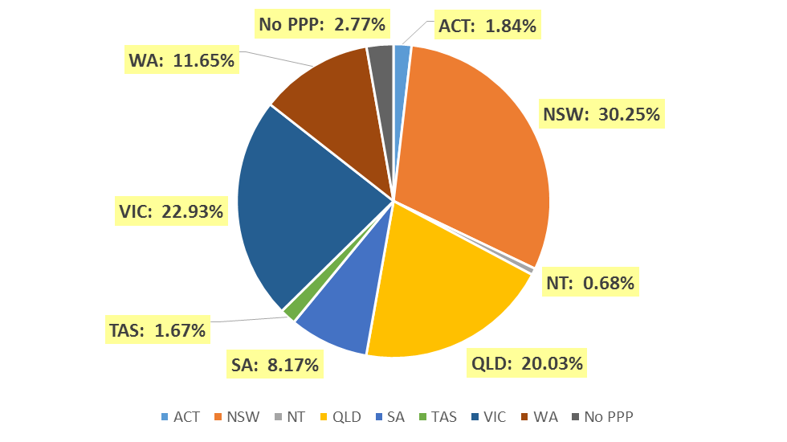

- Registration divisions
  - Dental practitioners - division(s) by state or territory
Divisions | ACT | NSW | NT | QLD | SA | TAS | VIC | WA | No PPP | Total
Dental Hygienist | 43 | 440 | 12 | 144 | 269 | 19 | 218 | 271 | 30 | 1,446
Dental Hygienist and Dental Prosthetist |  | 2 |  | 1 |  |  |  |  |  | 3
Dental Hygienist and Dental Prosthetist and Dental Therapist |  | 1 |  |  |  |  | 1 |  |  | 2
Dental Hygienist and Dental Therapist | 9 | 69 | 7 | 146 | 61 | 2 | 124 | 57 | 6 | 481
Dental Hygienist and Dental Therapist and Dentist |  | 1 |  | 2 | 1 |  |  |  |  | 4
Dental Hygienist and Dental Therapist and Oral Health Therapist |  |  |  | 3 |  |  |  |  |  | 3
Dental Hygienist and Dentist |  | 2 |  | 1 |  |  | 1 |  |  | 4
Dental Hygienist and Oral Health Therapist |  | 2 |  |  | 1 |  |  | 3 |  | 6
Dental Prosthetist | 16 | 413 | 5 | 275 | 65 | 49 | 353 | 89 | 3 | 1,268
Dental Prosthetist and Dental Therapist |  |  |  |  |  |  | 1 |  |  | 1
Dental Prosthetist and Dentist |  |  |  |  |  |  | 2 |  |  | 2
Dental Therapist | 19 | 208 | 16 | 183 | 85 | 48 | 158 | 290 | 8 | 1,015
Dental Therapist and Dentist |  |  |  |  |  |  | 1 |  |  | 1
Dental Therapist and Oral Health Therapist |  |  |  |  |  |  |  | 4 |  | 4
Dentist | 308 | 5,291 | 100 | 3,353 | 1,186 | 246 | 3,950 | 1,776 | 571 | 16,781
Dentist and Oral Health Therapist |  | 2 |  | 4 | 1 |  | 1 | 1 |  | 9
Oral Health Therapist | 19 | 364 | 13 | 387 | 166 | 11 | 341 | 127 | 5 | 1,433
Total | 414 | 6,795 | 153 | 4,499 | 1,835 | 375 | 5,151 | 2,618 | 623 | 22,463

- Registration type and divisions
  - Dental practitioners – registration type and division by state or territory
Registration Type | Divisions | ACT | NSW | NT | QLD | SA | TAS | VIC | WA | No PPP | Total
General | Dental Hygienist | 43 | 431 | 12 | 142 | 264 | 19 | 215 | 258 | 20 | 1,404
General | Dental Hygienist and Dental Prosthetist |  | 2 |  | 1 |  |  |  |  |  | 3
General | Dental Hygienist and Dental Prosthetist and Dental Therapist |  | 1 |  |  |  |  | 1 |  |  | 2
General | Dental Hygienist and Dental Therapist | 9 | 67 | 6 | 145 | 61 | 2 | 121 | 56 | 6 | 473
General | Dental Hygienist and Dental Therapist and Dentist |  | 1 |  | 2 | 1 |  |  |  |  | 4
General | Dental Hygienist and Dental Therapist and Oral Health Therapist |  |  |  | 3 |  |  |  |  |  | 3
General | Dental Hygienist and Dentist |  | 2 |  |  |  |  | 1 |  |  | 3
General | Dental Hygienist and Oral Health Therapist |  | 2 |  |  | 1 |  |  | 3 |  | 6
General | Dental Prosthetist | 15 | 400 | 5 | 270 | 64 | 48 | 342 | 86 | 1 | 1,231
General | Dental Prosthetist and Dental Therapist |  |  |  |  |  |  | 1 |  |  | 1
General | Dental Prosthetist and Dentist |  |  |  |  |  |  | 2 |  |  | 2
General | Dental Therapist | 19 | 196 | 16 | 179 | 83 | 47 | 148 | 280 | 7 | 975
General | Dental Therapist and Dentist |  |  |  |  |  |  | 1 |  |  | 1
General | Dental Therapist and Oral Health Therapist |  |  |  |  |  |  |  | 4 |  | 4
General | Dentist | 265 | 4,687 | 93 | 2,957 | 997 | 215 | 3,434 | 1,561 | 384 | 14,593
General | Dentist and Oral Health Therapist |  | 2 |  | 4 | 1 |  | 1 |  |  | 8
General | Oral Health Therapist | 18 | 360 | 13 | 380 | 162 | 11 | 337 | 126 | 3 | 1,410
Sub Total |  | 369 | 6,151 | 145 | 4,083 | 1,634 | 342 | 4,604 | 2,374 | 421 | 20,123
General and Specialist | Dentist | 38 | 477 | 4 | 323 | 142 | 28 | 404 | 181 | 46 | 1,643
Specialist | Dentist | 1 | 5 |  | 3 | 4 |  | 8 | 4 | 6 | 31
Limited | Dental Hygienist |  | 1 |  |  |  |  |  |  |  | 1
Limited | Dentist | 1 | 15 |  | 20 | 19 |  | 11 | 2 | 1 | 69
Limited | Oral Health Therapist |  |  |  |  |  |  | 1 |  |  | 1
Continued on next page

Registration Type | Divisions | ACT | NSW | NT | QLD | SA | TAS | VIC | WA | No PPP | Total
General and Non-practising | Dental Hygienist and Dentist |  |  |  | 1 |  |  |  |  |  | 1
General and Non-practising | Dentist and Oral Health Therapist |  |  |  |  |  |  |  | 1 |  | 1
Sub Total |  |  |  |  | 1 |  |  |  | 1 |  | 2
Non-practising | Dental Hygienist |  | 8 |  | 2 | 5 |  | 3 | 13 | 10 | 41
Non-practising | Dental Hygienist and Dental Therapist |  | 2 | 1 | 1 |  |  | 3 | 1 |  | 8
Non-practising | Dental Prosthetist | 1 | 13 |  | 5 | 1 | 1 | 11 | 3 | 2 | 37
Non-practising | Dental Therapist |  | 12 |  | 4 | 2 | 1 | 10 | 10 | 1 | 40
Non-practising | Dentist | 3 | 107 | 3 | 50 | 24 | 3 | 93 | 28 | 134 | 445
Non-practising | Oral Health Therapist | 1 | 4 |  | 7 | 4 |  | 3 | 1 | 2 | 22
Sub Total |  | 5 | 146 | 4 | 69 | 36 | 5 | 123 | 56 | 149 | 593
Total |  | 414 | 6,795 | 153 | 4,499 | 1,835 | 375 | 5,151 | 2,618 | 623 | 22,463

- Dental specialties
  - Dental practitioners – dental speciality by state or territory
Specialty | ACT | NSW | NT | QLD | SA | TAS | VIC | WA | No PPP | Total
Dento-maxillofacial radiology |  |  |  | 6 |  |  | 1 | 3 |  | 10
Endodontics | 6 | 49 | 1 | 29 | 15 | 3 | 40 | 17 | 5 | 165
Forensic odontology | 2 | 5 | 1 | 2 | 3 | 2 | 5 | 6 |  | 26
Oral and maxillofacial surgery | 3 | 55 | 1 | 45 | 17 | 5 | 51 | 23 | 7 | 207
Oral medicine |  | 7 |  | 5 |  |  | 12 | 8 | 3 | 35
Oral pathology |  | 7 |  | 4 | 3 |  | 4 | 4 | 2 | 24
Oral surgery |  | 38 |  | 4 |  |  | 7 | 2 | 1 | 52
Orthodontics | 12 | 184 | 2 | 126 | 54 | 13 | 138 | 58 | 20 | 607
Paediatric dentistry | 2 | 37 |  | 24 | 13 | 1 | 35 | 14 | 5 | 131
Periodontics | 9 | 58 |  | 42 | 15 | 4 | 58 | 32 | 5 | 223
Prosthodontics | 5 | 64 |  | 44 | 22 |  | 54 | 21 | 4 | 214
Public health dentistry (Community dentistry) |  | 3 |  | 1 | 2 |  | 8 | 1 | 1 | 16
Special needs dentistry |  | 2 |  | 4 | 2 |  | 7 |  | 1 | 16
Total | 39 | 509 | 5 | 336 | 146 | 28 | 420 | 189 | 54 | 1,726

- Endorsements
  - Dental practitioners – endorsements by state or territory
Endorsement | ACT | NSW | NT | QLD | SA | TAS | VIC | WA | No PPP | Total
Area of Practice – conscious sedation | 4 | 50 | 2 | 22 | 2 | 2 | 5 | 9 |  | 96

- Age group
  - Dental practitioners – by age group
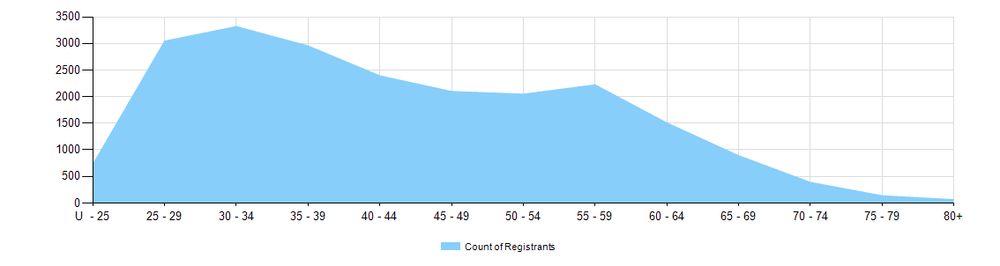

  - Dental practitioners – registration type by age group
Age Group | General | General and Specialist | Specialist | Limited |  |  | General and Non-practising | Non-practising | Total
 |  |  |  | Postgraduate training or supervised practice | Public interest | Teaching or research | General and Non-practising | Non-practising | Total
U - 25 | 945 |  |  |  |  |  |  | 4 | 949
25 - 29 | 3,156 | 2 |  | 11 |  |  | 1 | 47 | 3,217
30 - 34 | 3,141 | 110 | 2 | 10 |  | 5 | 1 | 82 | 3,351
35 - 39 | 2,677 | 283 | 15 | 4 |  | 11 |  | 58 | 3,048
40 - 44 | 2,137 | 216 | 5 | 1 |  | 9 |  | 46 | 2,414
45 - 49 | 1,895 | 180 | 6 |  |  | 7 |  | 48 | 2,136
50 - 54 | 1,782 | 194 | 2 |  |  | 7 |  | 42 | 2,027
55 - 59 | 1,927 | 239 |  |  |  | 3 |  | 69 | 2,238
60 - 64 | 1,283 | 192 |  |  |  | 1 |  | 71 | 1,547
65 - 69 | 742 | 123 | 1 |  |  | 1 |  | 49 | 916
70 - 74 | 302 | 66 |  |  |  |  |  | 41 | 409
75 - 79 | 97 | 26 |  |  |  | 1 |  | 17 | 141
80+ | 39 | 12 |  |  |  |  |  | 19 | 70
Total | 20,123 | 1,643 | 31 | 26 |  | 45 | 2 | 593 | 22,463

- Gender
  - Dental practitioners – registration type by gender
Gender | Registration Type | ACT | NSW | NT | QLD | SA | TAS | VIC | WA | No PPP | Total
Female | General | 227 | 2,919 | 81 | 2,064 | 955 | 160 | 2,413 | 1,410 | 188 | 10,417
Female | General and Specialist | 6 | 113 | 1 | 72 | 39 | 7 | 124 | 48 | 11 | 421
Female | Specialist |  | 2 |  |  | 1 |  | 5 | 2 |  | 10
Female | Limited |  | 10 |  | 8 | 10 |  | 4 | 2 |  | 34
Female | Non-practising | 4 | 69 | 2 | 37 | 20 | 2 | 59 | 35 | 73 | 301
Female | General and Non-practising |  |  |  | 1 |  |  |  | 1 |  | 2
Total Female |  | 237 | 3,113 | 84 | 2,182 | 1,025 | 169 | 2,605 | 1,498 | 272 | 11,185
Male | General | 142 | 3,232 | 64 | 2,019 | 679 | 182 | 2,191 | 964 | 233 | 9,706
Male | General and Specialist | 32 | 364 | 3 | 251 | 103 | 21 | 280 | 133 | 35 | 1,222
Male | Specialist | 1 | 3 |  | 3 | 3 |  | 3 | 2 | 6 | 21
Male | Limited | 1 | 6 |  | 12 | 9 |  | 8 |  | 1 | 37
Male | Non-practising | 1 | 77 | 2 | 32 | 16 | 3 | 64 | 21 | 76 | 292
Total Male |  | 177 | 3,682 | 69 | 2,317 | 810 | 206 | 2,546 | 1,120 | 351 | 11,278
Total |  | 414 | 6,795 | 153 | 4,499 | 1,835 | 375 | 5,151 | 2,618 | 623 | 22,463

  - Dental practitioners – percentage by gender
Gender | ACT | NSW | NT | QLD | SA | TAS | VIC | WA | No PPP | Total
Female | 57.2% | 45.8% | 54.9% | 48.5% | 55.9% | 45.1% | 50.6% | 57.2% | 43.7% | 49.8%
Male | 42.8% | 54.2% | 45.1% | 51.5% | 44.1% | 54.9% | 49.4% | 42.8% | 56.3% | 50.2%

